4. (20 pts) (Ex 1.8.2) The dining philosophers problem was invented by E. W. Dijkstra, a concurrency pioneer, to clarify the notions of deadlock and starvation freedom. Imagine five philosophers who spend their lives just thinking and feasting. They sit around a circular table with five chairs. The table has a big plate of rice. However, there are only five chopsticks (in the original formulation forks) available, as shown in Fig. 1.5. Each philosopher thinks. When he gets hungry, he sits down and picks up the two chopsticks that are closest to him. If a philosopher can pick up both chopsticks, he can eat for a while. After a philosopher finishes eating, he puts down the chopsticks and again starts to think.

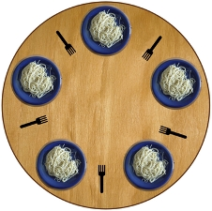

a. What is wrong with everybody doing the following - other than that the philosophers never get up from the table?

1. think for a while
2. get left chopstick
3. get right chopstick
4. eat for a while
5. return left chopstick
6. return right chopstick
7. return to 1

b. How can the above be fixed to avoid deadlocks?

c. Is your solution starvation free? Literally!

8. (10 pts) Describe the environment in which a wait () call is legal?